**Plot a histogram in MATLAB using the values generated by Nakagami distribution for NetSim (using .m file)**

**Software Used:** NetSim Standard v10 (32-bit), Visual Studio 2015, MATLAB 2011a (32-bit)

In this example we will replace the default Rayleigh Fading (part of the path loss calculation) used in NetSim, with a Fading Power calculated using the Nakagami Distribution from MATLAB

**Procedure:**

1. Create a NetSim_MATLAB.m file and place the file inside <Path where MATLAB is installed>.

The NetSim_MATLAB.m file contains the following code:

function WLAN=NetSim_MATLAB(choice,varargin)

switch(choice)

case 'nakagami'

h=ProbDistUnivParam('nakagami',[varargin{1},varargin{2}]);

i=random(h,1);

fid = fopen('plotvalues.txt','a+');

fprintf(fid,'%f',i);

fprintf(fid,'\r\n');

fclose('all');

WLAN=i;

case 'plothistogram'

fid=fopen('plotvalues.txt');

mx=fscanf(fid,'%f');

hist(mx);

fclose('all');

end

1. Open MATLAB_Interface.c file and change fn_netsim_matlab_run() function as followed

double fn_netsim_matlab_run(char *arr)

{

//write your own implementation here

int nakagami_shape=5,nakagami_scale=2;

if(strcmp(arr,"nakagami")==0)

{

engPutVariable(ep,"h",h);

sprintf(buf,"h=NetSim_MATLAB('nakagami',%d,%d)",nakagami_shape,nakagami_scale);

status=engEvalString(ep,buf);

out=engGetVariable(ep,"h");

result=mxGetPr(out);

return *result;

}

else if(strcmp(arr,"plothistogram")==0)

{

status=engEvalString(ep,"NetSim_MATLAB('plothistogram')");

return 0;

}

else

return 0;

}

1. A call to the NetSim_MATLAB() function inside the NetSim_MATLAB.m file is made, for fading power calculation with parameters distribution(‘nakagami’), nakagami_shape and nakagami_scale parameters are passed from NetSim.
2. A call to the NetSim_MATLAB() function inside the NetSim_MATLAB.m file is made, for plotting histogram for the values generated by MATLAB..
3. 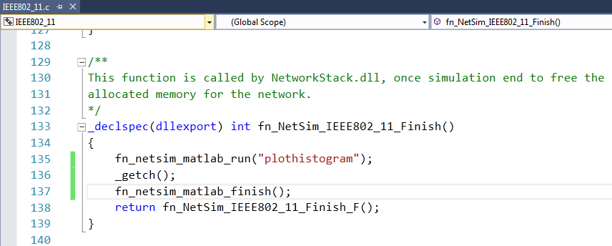Also add the following call to fn_netsim_matlab_run("plothistogram") function along with a _getch() to plot the histogram before closing the MATLAB Engine.
4. Similarly in the call made to fn_netsim_matlab_run(“nakagami”) function in IEEE802_11_Phy.c file add the parameter “nakagami” as shown below:-

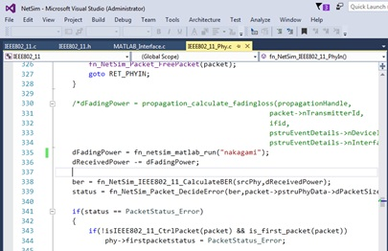

1. Also modify the function definition of fn_netsim_matlab_run(char *arr) function in IEEE802_11.h file as shown below:-

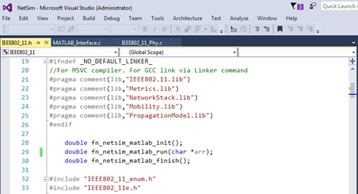

1. Right Click on IEEE802_11 project and select Rebuild.
2. Now Replace the newly build libIEEE802.11.dll from the DLL folder in the NetSim bin folder after renaming the original libIEEE802.11.dll file.
3. Create a Network scenario involving IEEE802_11 say MANET, and set the Fading Figure value in the Multipoint to Multipoint Link properties to 1 to ensure that Rayleigh fading is set.
4. You will find that once the Simulation is run MATLAB Command Window starts and once the Simulation is over a histogram is displayed in MATLAB for the values that were generated using nakagami distribution.

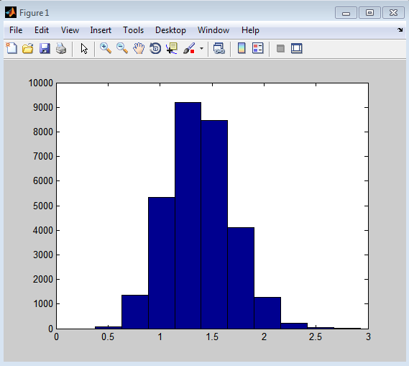

1. The graph and the MATLAB windows get closed once you press any key.

You can also debug the code to understand the communication between NetSim and MATLAB as explained in the DEBUGGING section in other document of this project.